School Name: Kalon Prep Academy
Charter Number:4290
Date: 6/21/21
Address:
1877 Aga Drive
Alexandria, MN 56308
Board Member Names: |  | Present | Absent
Melody Warren
Quinto Lotti
Trisha Reed
Byron Peterson
Dennis Johnson
Chris Kragenbring
Heather Netland
- Call to Order/ Mindful Minute
By: |  | Time:
Declaration of Conflict of Interest, if any:
Community Comment:
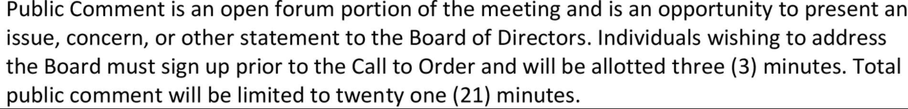
- Approval of the Agenda
Motion
Made by: Seconded by:
Discussion:
Vote
 | Yea | Nay | Abstain
Melody Warren
Quinto Lotti
Trisha Reed
Byron Peterson
Dennis Johnson
Chris Kragenbring
Heather Netland

- Approval of Consent Agenda
Motion
Made by: Seconded by:
Discussion:
Vote
 | Yea | Nay | Abstain

- Approval of Consent Agenda - Appropriation of Money
Motion
Made by: Seconded by:
Discussion:
Vote
 | Yea | Nay | Abstain
Melody Warren
Quinto Lotti
Trisha Reed
Byron Peterson
Dennis Johnson
Chris Kragenbring
Heather Netland

- Treasurer’s Report
Motion
Made by: Seconded by:
Discussion:
Vote
 | Yea | Nay | Abstain
Melody Warren
Quinto Lotti
Trisha Reed
Byron Peterson
Dennis Johnson
Chris Kragenbring
Heather Netland

- Policy Development, Review, and Revision
Motion
Made by: Seconded by:
Discussion:
Vote
 | Yea | Nay | Abstain

Required CSP Policies: Conflict of Interest, Depreciation, Procurement, Credit/Debit, Fair & Open Hiring

- Board Business (old and new)
Motion
Made by: Seconded by:
Discussion:
Vote
 | Yea | Nay | Abstain

- Building Update: Melody
- Fundraising Update: Quinto
- Staff Update: Quinto

- Board Training:
Description
Date:
Trainer:

Identify Items for Next Month’s Agenda

IQS Authorizer- Communication and Updates

- Mindful Minute/Adjournment
Motion
Made by: Seconded by:
Discussion:
Vote
 | Yea | Nay | Abstain

Authorizer: Innovative Quality Schools (IQS)
P.O. Box 580
Hutchinson, MN 55350
651-234-0900

