School Name: Kalon Prep Academy
Charter Number: 4290
Date: 7/19/21
Address:
1877 Aga Drive Suite 220
Alexandria, MN 56308
Board Member Names: |  | Present | Absent
Melody Warren: Chair
Quinto Lotti: Treasurer
Trisha Reed : Parent
Byron Peterson: Community Member
Dennis Johnson: Community Member
Heather Netland : Teacher
Chris Kragenbring: Executive Director (ex officio)
- Call to Order /Mindful Minutes
By: |  | Time:
Declaration of Conflict of Interest, if any:
Community Comment:
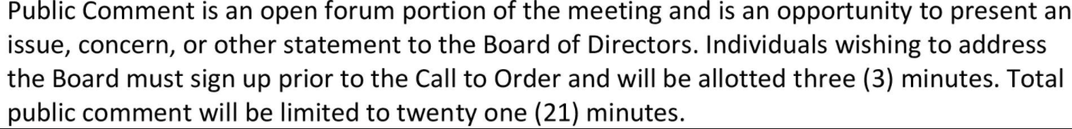
- Approval of the Minutes
Motion
Made by: Seconded by:
Discussion:
Vote
 | Yea | Nay | Abstain
Melody Warren
Quinto Lotti
Trisha Reed
Byron Peterson
Dennis Johnson
Heather Netland

- Approval of Agenda

-Bids: Strengths Coaching, IT, Summit Fire Protection
-Building Updates
-Enrollment Update
-CSP
-Staffing update (part-time hires)
Motion
Made by: Seconded by:
Discussion:
Vote
 | Yea | Nay | Abstain

- Approval of Consent Agenda - Appropriation of Money
Bill from Forum Communications: ad in Lakeland Shopping Guide - $550

Motion
Made by: Seconded by:
Discussion:
Vote
 | Yea | Nay | Abstain
Melody Warren
Quinto Lotti
Trisha Reed
Byron Peterson
Dennis Johnson
Heather Netland

- Treasurer’s Report
Motion
Made by: Seconded by:
Discussion:
Vote
 | Yea | Nay | Abstain
Melody Warren
Quinto Lotti
Trisha Reed
Byron Peterson
Dennis Johnson
Heather Netland

- Policy Development, Review, and Revision
Motion
Made by: Seconded by:
Discussion:
Vote
 | Yea | Nay | Abstain

- Board Business (old and new)

-Bids: Strengths Coaching, IT
-Building Updates
-Enrollment
-CSP
-Staffing update
-Emails
Motion
Made by: Seconded by:
Discussion:
Vote
 | Yea | Nay | Abstain

- Board Training:
Description
Date:
Trainer:

Identify Items for Next Month’s Agenda

IQS Authorizer- Communication and Updates

- Mindful Minutes /Adjournment
Motion
Made by: Seconded by:
Discussion:
Vote
 | Yea | Nay | Abstain

Authorizer: Innovative Quality Schools (IQS)
P.O. Box 580
Hutchinson, MN 55350
651-234-0900

