Agenda:

- Call to Order
- Moment of mindfulness
- Approval of Agenda
2.5. Karin Weigel to address the board
- Consent agenda: appropriation of $
- Policy Review
- Board Business: Old & New
a. Enrollment Update (Chris)
b. Building Update (Melody & Chris)
c. Fundraising Update (Chris)
d. CSP Update (Chris)

School Name: Kalon Prep Academy
Charter Number: 4290
Date: July 5, 2021
Address:
1877 Aga Drive
Alexandria, MN 56308
Board Member Names: |  | Present | Absent
Melody Warren
Quinto Lotti
Trisha Reed
Byron Peterson
Dennis Johnson
Chris Kragenbring
Heather Netland
- Call to Order/ Mindful Minutes
By: |  | Time:
Declaration of Conflict of Interest, if any:
Community Comment:
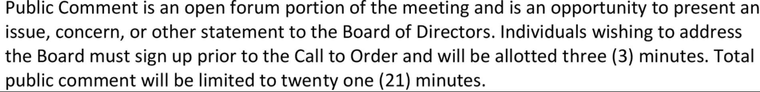
- Approval of the Agenda
Motion
Made by: Seconded by:
Discussion:
Vote
 | Yea | Nay | Abstain
Melody Warren
Quinto Lotti
Trisha Reed
Byron Peterson
Dennis Johnson
Chris Kragenbring
Heather Netland

2.5 KARIN WEIGEL

- Approval of Consent Agenda - Appropriation of Money

Hilltop Lumber, Kuhl Construction, Carpet One, Service Master, Bill Olson Plumbing, Schlangen Heating, Jim’s Electric, Colorful Seasons, Gardonville Cooperative, Innovative Office Solutions, Forum Communications, Dorsey & Whitney legal services
Motion
Made by: Seconded by:
Discussion:
Vote
 | Yea | Nay | Abstain
Melody Warren
Quinto Lotti
Karin Weigel
Byron Peterson
Dennis Johnson
Chris Kragenbring
Heather Netland

- Policy Development, Review, and Revision
Report back on document retention recommendations (Chris) -5 minutes
Motion
Made by: Seconded by:
Discussion:
Vote
 | Yea | Nay | Abstain

- Board Business (old and new)

- Board Business: Old & New

a. Enrollment Update (Chris)
b. Building Update (Melody & Chris)
c. Fundraising Update (Chris)
d. CSP Update (Chris)

Motion
Made by: Seconded by:
Discussion:
Vote
 | Yea | Nay | Abstain

- Board Training:
Description
Date:
Trainer:

Identify Items for Next Month’s Agenda

IQS Authorizer- Communication and Updates

- Adjournment/ Mindful Minutes
Motion
Made by: Seconded by:
Discussion:
Vote
 | Yea | Nay | Abstain

Authorizer: Innovative Quality Schools (IQS)
P.O. Box 580
Hutchinson, MN 55350
651-234-0900

